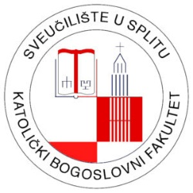

29th International Theological Symposium

Theology and literature: faith, experience and art

Split, 19-20 October 2023

APPLICATION FORM

1. Full Name

2. Organization

3. Mailing address

4. Phone

I am applying for participation with:

5. Title of the paper/poster:
-
7. Abstract (up to 200 words) with key words:
-
8. Short CV (up to 150 words):
-

Please send us your application form to mail address ivan.bodrozic@gmail.com

