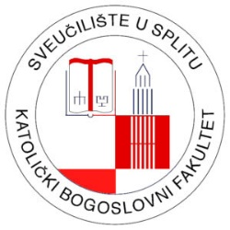

An International Conference on the
25th anniversary of the pastoral visit of Pope John Paul II.
to Solin and Split

Solin, 5-6 October 2023

First call
APPLICATION FORM

1. Full Name

2. Organization

3. Mailing address

4. Phone

I am applying for participation with:

5. Title of the paper/poster:
-
7. Abstract (up to 200 words) with key words:
-
8. Short CV (up to 150 words):
-

Please send us your application form by May 12, 2023, at the mail address ivan.bodrozic@gmail.com

