**SVEUČILIŠTE U SPLITU i**

**CENTAR “DON FRANE BULIĆ” KATOLIČKOG BOGOSLOVNOG FAKULTETA**

**u suradnji s**

**ARHEOLOŠKIM MUZEJEM U SPLITU**

**Vas pozivaju na predavanja dvojice znanstvenika s talijanskog Sveučilišta u Salernu**

**PRVI SUSRET**

**Mario CASILLO**

***IoT and Digital Twins.***

***Advanced Technologies for the Conservation and Enhancement of Cultural Heritage***

Split, Arheološki muzej Split, Zrinsko-frankopanska 25

Ponedjeljak, 2. lipnja 2025., u 12.00 sati

**DRUGI SUSRET**

**Mario CASILLO**

***IoT and Digital Twins: Intelligent Technologies for the Preservation and Enhancement of Cultural Heritage and Historical Archives***

Split, Katolički bogoslovni fakultet, Zrinsko-frankopanska 19

Utorak, 3. lipnja 2025., u 9.00 sati

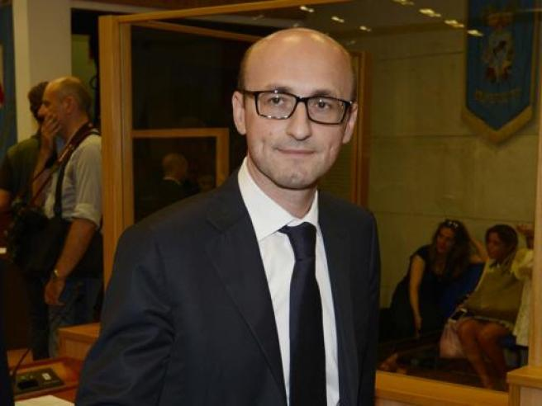

Mario CASILLO, PhD

Research Fellow and adjunct Professor in Computer Science, Department of Cultural Heritage Sciences, University of Salerno

Their main research interest include Machine Learning, Context-Aware Computing, Digital Twins, Racommander Systems and digital archiving. They explore how advanced digital technologies can be integrated into innovative methodologies for the conservation, enhancement and sustainable managment of Cultural Heritage.

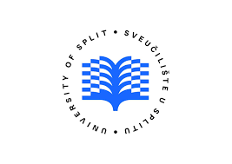 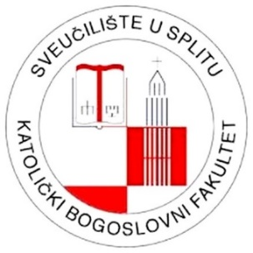 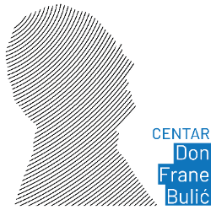 Slika na kojoj se prikazuje kuća, skeč, ilustracija, dizajn

Opis je automatski generiran