Postdoctoral Fellowship Training Scheme for Incoming Postdocs to Malta (PF2MT)
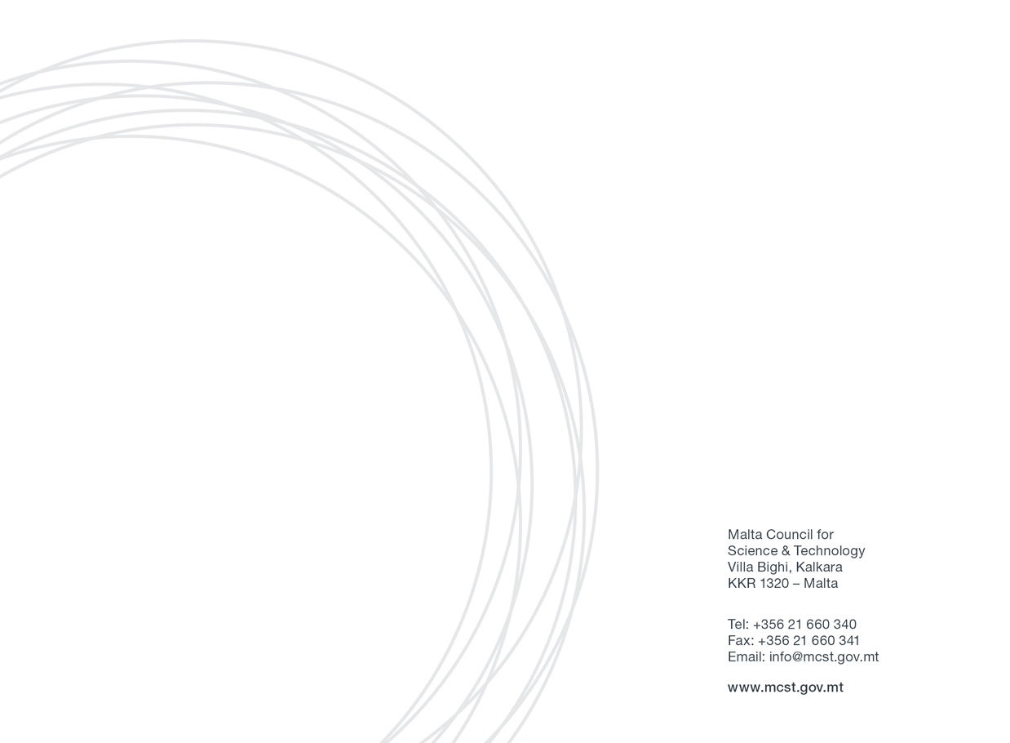
Application Form 2023:

Section One: Applicant’s Details
Applicant Details

Name and Surname
Designation
Country of residence (this will determine the lump sum)
Residing/living/working in Europe, EU Member State/Associated Country  (this will determine the lump sum) | Yes/No
Email
Mob. Number

Details of the host entity/beneficiary:

Name of host entity/beneficiary
Contact Details of the Supervisor | Name and Surname: | Designation:
Contact Details of the Supervisor | Name and Surname: | Email:
Contact Details of the Supervisor |  | Tel. No.:
Contact Details of the Supervisor |  | Mob. No. (optional):

Kindly note that MCST will contact the host entity/supervisor in order to confirm their intentions.

SECTION TWO: PROJECT DETAILS
Proposed Project title (if known already):

Proposed project idea (project brief) (maximum 500 words)

SECTION THREE: DECLARATION BY APPLICANTS
Declaration by Researcher

I confirm that:  The information given in this form is accurate to the best of my knowledge. I understand that if it is later established that I misrepresented myself and I am not eligible for this Scheme, I will be required to pay for the services received. | I agree
I accept and confirm that the personal data and project/activities proposal content information can be passed on to the Malta Council for Science and Technology to be used solely for the purposes of administering, processing, and reviewing of the application. | I agree
I confirm that full and updated Curriculum Vitae (CV) is attached to this application form. | I agree
I confirm that I comply with the Postdoctoral Fellowship eligibility and mobility rules of the Marie Sklodowska Curie Actions of the Horizon Europe programme. | I agree
I confirm that I will participate during the full day proposal writing training in Malta on 12th July. | I agree
I confirm that my intention is to submit a MSCA Postdoctoral Fellowship (PF) proposal for the call with deadline 13th September 2023 and I will provide proof of submission of proposal to MCST. | I agree
I confirm that I will share a draft digital copy of the MSCA PF project proposal to the Horizon Europe unit at MCST for their review. This shall be sent by not later than 1 month before the submission deadline. | I agree

Signature of the Applicant: | Date:  Sign:

